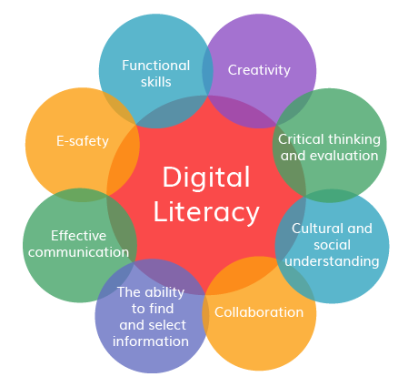

DIGITAL LITERACY
Project

Name: Tanishque Chandan
Registration no.: 25BAS10067
AEROSPACE ENGINEERING – 1st year
Course code: CSE-0001
29th MARCH 2026

Introduction
As a Student Digital Ambassador, this project is undertaken with the aim of promoting digital literacy and responsible online behaviour among fellow students. In the present technology-driven environment, individuals frequently interact with various digital platforms; however, a comprehensive understanding of their effective, ethical, and secure usage is often lacking. This project is centred on the development of a comprehensive Digital Literacy Portfolio that demonstrates key competencies such as building a professional online presence, utilizing digital tools efficiently, and maintaining proper online communication practices.
The project is organized into five distinct tasks, each addressing a crucial aspect of digital literacy, including awareness creation, portfolio development, platform exploration, email etiquette, and cybercrime prevention. Through this initiative, the project aspires to enhance digital awareness and equip students with essential skills required for academic and professional success.

Task 1: Create a Digital Literacy Awareness Infographic
For this project, I used Canva to create a visual resource on digital literacy. Canva made it easy to arrange my content clearly and present it in an attractive way with simple sections.
My design covers three main topics: what digital literacy means, useful digital tools for students, and safe internet practices. I added a short and simple definition of digital literacy to help students understand its importance. I also included useful tools like Google Docs, Microsoft Word, and GitHub to show how students can improve their studies and skills. In addition, I explained important safety tips such as using strong passwords, avoiding suspicious links, protecting personal information, and enabling two-factor authentication. The overall design is simple, neat, and easy for students to understand.
One challenge I faced was including all the important points without making the design look too crowded. However, this experience helped me improve my ability to organize information clearly and present it in a more effective way.

Task 2: Build your Student Digital Portfolio
For this task, I created and updated my profiles on GitHub, LinkedIn, and Kaggle Each platform is useful in a different way for building a professional online presence.
GitHub is used to share and manage coding projects. I created my profile README and will upload my projects regularly to show my programming skills. In the next four years, I plan to use GitHub to practice coding and build a strong project portfolio.
LinkedIn is a platform for professional networking. I have added my education details, and I will use it to connect with other students and professionals, learn about internships, and share my achievements.
Kaggle is mainly used for academic and research purposes. I plan to use it to read research papers, gain knowledge, and share my own work in the future.
Overall, I will use these platforms to improve my skills, grow my network, and prepare for my future career.

Task 3: Explore Coding & Collaboration Platforms
I used HackerRank as a coding platform to solve a beginner-level problem. The platform provides a variety of coding challenges that help improve programming skills and logical thinking. I solved a basic problem called "Solve Me First" which involved simple input and output operations.
Additionally, I created a Google Form consisting of five questions related to digital literacy and online platforms. The form included both multiple-choice and short answer questions. I also collected responses to analyze the data.
These platforms are very useful for academic and professional development as they enhance technical knowledge, problem-solving skills, and data collection abilities.

Task 4: Professional Email & Etiquette Guide
During our Class 12 group project, our physics teacher shared important instructions on the class WhatsApp group late at night. I muted the group to avoid distractions and didn’t check it until the next day. As a result, I missed a major update about a change in submission format. I completed the entire project in the old format, while my classmates followed the new one. This caused confusion, last-minute stress, and even affected my marks.
This problem happened because of poor digital communication habits—both mine and the group’s. To avoid this, I could have checked important messages regularly or kept notifications on for academic groups. Also, the teacher could have ensured the message was acknowledged by everyone. Clear communication and timely checking could have prevented the issue.

Task 5: Cybercrime Awareness
While researching cyber safety, what surprised me the most was how easily small and careless actions can turn into serious problems. Simple things like clicking on an unknown link, downloading a file, or scanning a random QR code can lead to losing money or personal information within minutes. I also found it surprising that many scams are specially designed to target college students. These scams often come in the form of fake internship offers, scholarship messages, or urgent payment requests that look very real. I did not realize before how cleverly these frauds are planned to trick people.
Another surprising thing was how quickly money can be stolen through UPI if someone shares their OTP or PIN by mistake. Even a small delay in reporting can make it hard to recover the lost money. This made me understand the importance of being alert all the time while using the internet.
As a result of this learning, one habit I will change is being more careful and thinking before I click or respond to anything online. I will always check the sender’s details, verify UPI requests properly, and never scan unknown QR codes. I will also make sure to use strong passwords and enable two-factor authentication on all my important accounts. These small changes will help me stay safe and avoid online scams.

Conclusion
This project, undertaken as a Student Digital Ambassador, has been an insightful journey into the evolving landscape of digital literacy. It has enabled a deeper understanding of how digital tools and platforms can be utilised not only efficiently but also ethically and responsibly. Each task contributed to strengthening essential competencies such as professional communication, online presence management, and awareness of cyber threats.
Furthermore, the project underscored the importance of being vigilant and informed in digital spaces. It has helped in cultivating a sense of responsibility towards safe online practices while also encouraging the dissemination of this awareness among peers. Overall, this experience has been instrumental in preparing for both academic and professional environments in an increasingly digital world.

REFRENCES:
Canva.com
github.com
linkedin.com
hackerrank.com
codechef.com
forms.google.com
cybercrime.gov.in
Cyber Crime Helpline 1930 (24x7 phone)

